CAESAR CIPHER PROGRAM

**1. Introduction**

The project implements a basic encryption and decryption system using the Caesar Cipher algorithm. The Caesar Cipher is a substitution cipher where each letter in the plaintext is shifted by a fixed number of positions down or up the alphabet. This project aims to demonstrate the use of simple cryptographic techniques, as well as to practice coding in C++.

**2. Project Overview**

The program consists of two main functionalities:

* **Encryption**: The user provides an input text, and the program shifts each letter by a fixed number of positions in the alphabet to generate the encrypted text.
* **Decryption**: The user provides the encrypted text, and the program reverses the shifting process to retrieve the original message.

Both operations only work with uppercase English letters, ensuring simplicity and clarity in the implementation.

**3. Design and Architecture**

The program is structured in two main functions:

* cesarEncrypt(): This function performs the encryption. It accepts an input string of uppercase letters and shifts each letter by a fixed amount (3 positions in this case) to produce the encrypted text.
* cesarDecrypt(): This function performs the decryption. It accepts an encrypted string and reverses the shift applied during encryption to recover the original text.

The main program calls these functions in sequence, first encrypting a user-provided text and then decrypting the result.

**4. Encryption Process**

The encryption is based on a Caesar Cipher with a fixed shift of 3 positions. Each letter in the input text is mapped to a new letter that is three positions earlier in the alphabet. For example:

* 'A' becomes 'X'
* 'B' becomes 'Y'
* 'C' becomes 'Z'
* 'D' becomes 'A'
* And so on...

**5. Decryption Process**

The decryption is the reverse of the encryption process. Each letter in the encrypted text is mapped to a new letter that is three positions later in the alphabet. For example:

* 'X' becomes 'A'
* 'Y' becomes 'B'
* 'Z' becomes 'C'
* 'A' becomes 'D'
* And so on...

**6. Input and Output**

The program prompts the user to enter a text for encryption and displays the encrypted result. Then, it asks for the encrypted text and outputs the decrypted message. The input is restricted to uppercase English letters only to maintain simplicity and avoid errors in the ciphering process.

**7. Code Implementation**

The core of the program is implemented using simple for loops and switch statements to handle the shifting of characters. The encryption and decryption processes are straightforward, ensuring that the program is easy to understand and modify. The use of getline() ensures that the program can handle multi-word inputs.

**8. Challenges and Limitations**

* The program currently only supports uppercase English letters. It would be beneficial to extend it to handle lowercase letters and special characters.
* The fixed shift of 3 characters is a limitation of this basic implementation. A more flexible approach would allow the user to specify the shift value.
* Error handling is minimal, and the program assumes that the user inputs valid characters (uppercase letters). Invalid inputs are simply rejected without further processing.

**9. Conclusion**

This project successfully implements a basic Caesar Cipher encryption and decryption system. It demonstrates the fundamental concepts of cryptography and provides an introduction to how ciphers can be implemented programmatically. The code is simple, but it serves as a good starting point for more advanced cryptographic techniques.

Here is the example Alphabet which I used in this program:

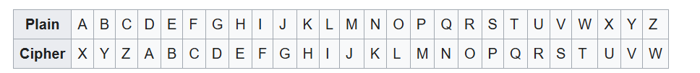

Code:

#include <iostream>

#include <string>

using namespace std;

void cesarEncrypt() {

cout << "Cesar Cryptography Program\n";

cout << "\n";

cout << "Please enter a text and this program will encrypt the entered text.\n";

string arr;

cout << "Enter text (uppercase English letters only): ";

getline(cin, arr);

cout << "Encrypted text: ";

for (char c : arr) {

switch (c) {

case 'A':

cout << "X";

break;

case 'B':

cout << "Y";

break;

case 'C':

cout << "Z";

break;

case 'D':

cout << "A";

break;

case 'E':

cout << "B";

break;

case 'F':

cout << "C";

break;

case 'G':

cout << "D";

break;

case 'H':

cout << "E";

break;

case 'I':

cout << "F";

break;

case 'J':

cout << "G";

break;

case 'K':

cout << "H";

break;

case 'L':

cout << "I";

break;

case 'M':

cout << "J";

break;

case 'N':

cout << "K";

break;

case 'O':

cout << "L";

break;

case 'P':

cout << "M";

break;

case 'Q':

cout << "N";

break;

case 'R':

cout << "O";

break;

case 'S':

cout << "P";

break;

case 'T':

cout << "Q";

break;

case 'U':

cout << "R";

break;

case 'V':

cout << "S";

break;

case 'W':

cout << "T";

break;

case 'X':

cout << "U";

break;

case 'Y':

cout << "V";

break;

case 'Z':

cout << "W";

break;

default:

cout << "\nInvalid character encountered. Please enter uppercase English letters only.\n";

return;

}

}

cout << "\n";

}

void cesarDecrypt() {

cout << "\nCesar Decryption Program\n";

cout << "\n";

cout << "Please enter an encrypted text and this program will decrypt it.\n";

string arr;

cout << "Enter encrypted text (uppercase English letters only): ";

getline(cin, arr);

cout << "Decrypted text: ";

for (char c : arr) {

switch (c) {

case 'X':

cout << "A";

break;

case 'Y':

cout << "B";

break;

case 'Z':

cout << "C";

break;

case 'A':

cout << "D";

break;

case 'B':

cout << "E";

break;

case 'C':

cout << "F";

break;

case 'D':

cout << "G";

break;

case 'E':

cout << "H";

break;

case 'F':

cout << "I";

break;

case 'G':

cout << "J";

break;

case 'H':

cout << "K";

break;

case 'I':

cout << "L";

break;

case 'J':

cout << "M";

break;

case 'K':

cout << "N";

break;

case 'L':

cout << "O";

break;

case 'M':

cout << "P";

break;

case 'N':

cout << "Q";

break;

case 'O':

cout << "R";

break;

case 'P':

cout << "S";

break;

case 'Q':

cout << "T";

break;

case 'R':

cout << "U";

break;

case 'S':

cout << "V";

break;

case 'T':

cout << "W";

break;

case 'U':

cout << "X";

break;

case 'V':

cout << "Y";

break;

case 'W':

cout << "Z";

break;

default:

cout << "\nInvalid character please just enter uppercase English letters only.\n";

return;

}

}

cout << "\n";

}

int main() {

cesarEncrypt();

cesarDecrypt();

return 0;

}

OUTPUT:

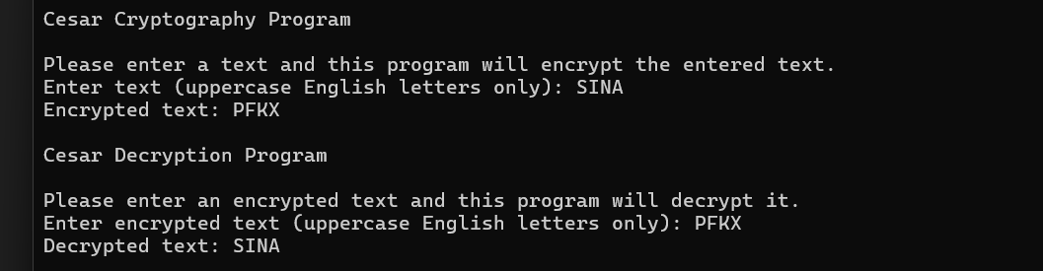

HÜSEYİN ÖZAYDİN